Form 6

A68

Construction Lien Act

CERTIFICATE OF SUBSTANTIAL PERFORMANCE
OF THE CONTRACT UNDER SECTION 32 OF THE ACT

City of Toronto
(County/District or Regional Municipality/City or Borough of Municipality of Metropolitan Toronto
in which premises are situate)

100 Queen St. W. Toronto ON M5H 2N2
(Street address and city, town, etc., or, if there is no street address, the location of the premises)

This is to certify that the contract for the following improvement:
Streetscape Construction for City of Toronto Transportation Services Division at Albion Road and Islington Ave. Tender 217-2019 PO # 6050956

(short description of the improvement)

to the above premises was substantially performed on April 22, 2021

(date substantially performed)

Date certificate signed: April 22, 2021 |  |  | 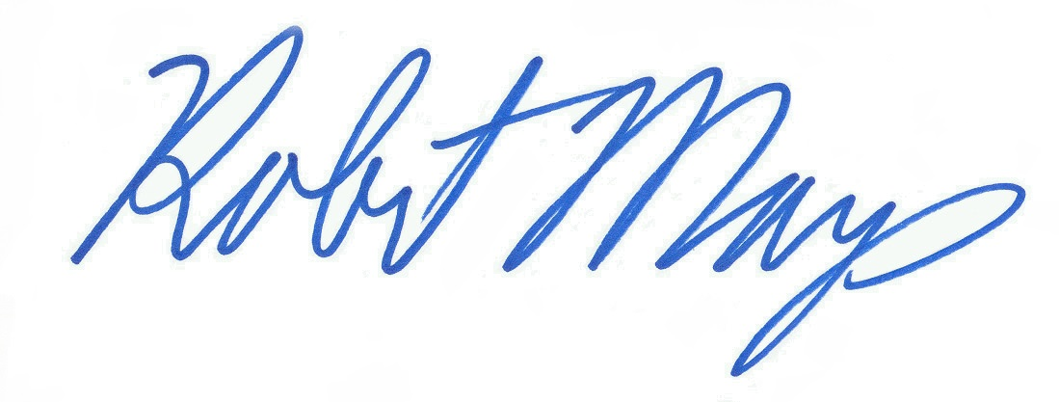
 |  |  | (payment certifier where there is one)
 |  |  | (owner and contractor, where there is no payment certifier)
 | Name of owner | City of Toronto
 | Address for service | City Hall, 17th Fl., East Tower, 100 Queen St W Toronto ON M5H 2N2
 | Name of contractor | Midome Construction Services Ltd.
 | Address for service | 200 Midwest Road, Toronto, Ontario, M1P 3A9
 | Name of payment certifier | Robert Mays
 |  | (where applicable)
 | Address | City Hall, 17th Fl. East Tower, 100 Queen St W Toronto ON M5H 2N2

(Use A or B whichever is appropriate)

A. Identification of premises for preservation of liens:
(where liens attach to premises, reference to lot and plan or instrument registration number)

B. Office to which claim for lien and affidavit must be given to preserve lien:
City Clerk's Office, 10th Floor, West Tower, City Hall, 100 Queen St W, Toronto ON M5H 2N2
(where liens do not attach to premises) R.R.O 1990, Reg. 175, Form 6

